MACEDONIA CHURCH OF GROVETOWN
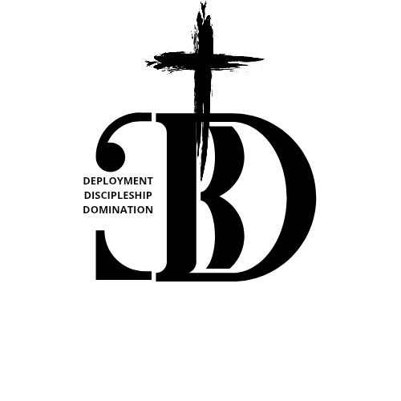
2026 Fasting Manual
For Godliness (Christlike Life)
MOMENTUM 2.0
OUR YEAR OF DEPLOYMENT, DISCIPLESHIP & DOMINATION
Matthew 11:11-12

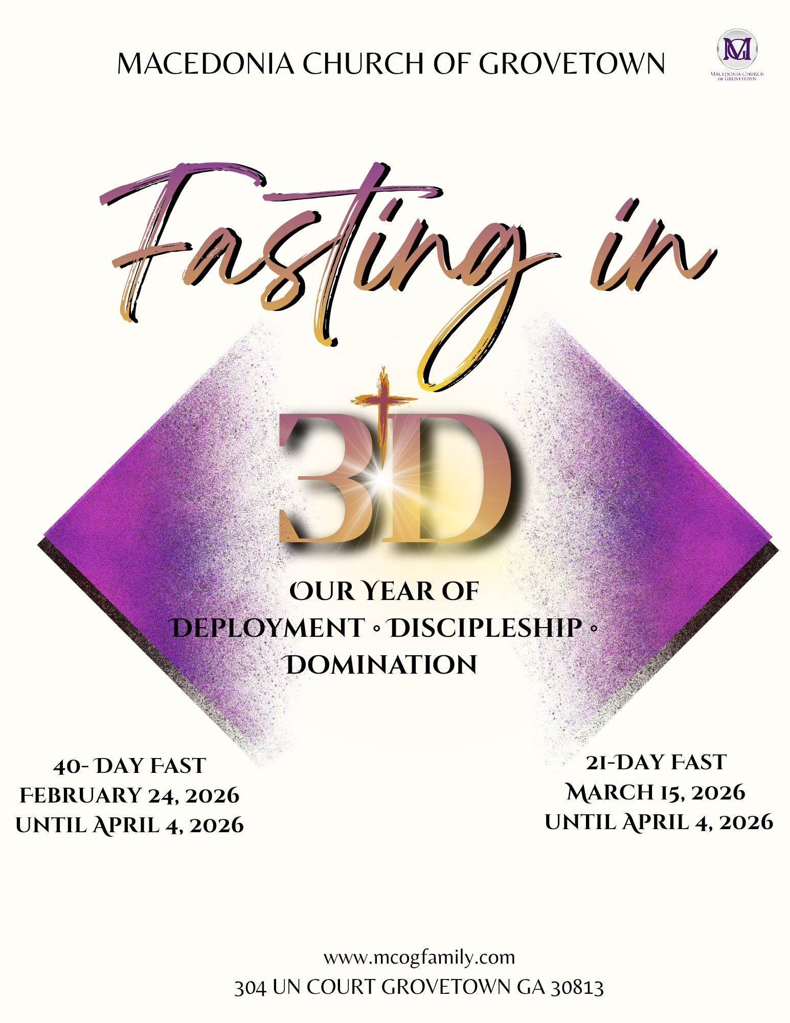
Due to health restrictions, some people may not be able to complete every aspect of the fast. Please consult your doctor before starting this fast. At a minimum, go as far as your health will allow.


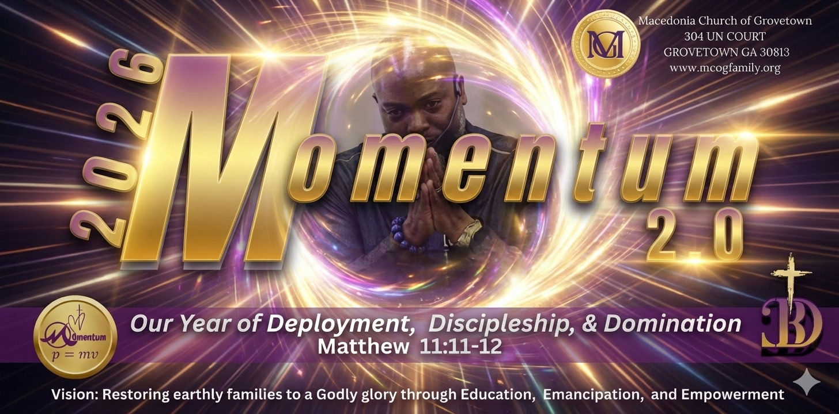

Welcome to a transformative journey—a sacred invitation to deepen your relationship with God and experience the miraculous power of fasting. Over the past few years, we have witnessed the divine hand of the Lord guiding us through profound revelations and calls to action. In 2017, God instructed us to embrace a new dimension of service, setting the stage for a life dedicated to His purpose. The following year, He called us to unlimited love, challenging us to embody His grace, patience, and compassion in every interaction.
As we continued to seek His will, 2019 brought a vision to build a multigenerational legacy in Christ, reminding us that our faith extends beyond ourselves. It’s a mandate we should remember with each divine mandate God gives: to impact future generations, to remind them of God, and to follow Him in all we do. In 2020, the Lord granted us spiritual clarity, leading us to unify as one body in Christ. 2021 served a powerful reminder that together, we are stronger, and that unity is where God commands His blessings. The mandate to activate our faith came in 2022, igniting a fervent desire for action within our hearts. In 2023, we experienced God working radically in us, a testament to His faithfulness and ability to transform lives by our hands. 2024 marked our “Year of Open Doors,” a season of unprecedented opportunities and blessings.
In 2025, we propelled into our “Year of Momentum,” where God calls us to take the limits off our spiritual lives. As Ephesians 3:20 (KJV) proclaims, “Now unto him that is able to do exceedingly abundantly above all that we ask or think, according to the power that worketh in us,” we are invited to embrace unhinged momentum in every aspect of our lives—our worship, our work, our families, and our thinking. In this season of consecration, we should assess where we have limited God and how we can open ourselves to the unimaginable as we enter 2026, where God calls us to live in His will and exhibit virtues such as righteousness, perseverance, and love.
Momentum 2.0 is our year of Deployment, Discipleship, and Domination. Matthew 11:11-12 KJV says, "Verily I say unto you, among them that are born of women there hath not risen a greater than John the Baptist: notwithstanding he that is least in the kingdom of heaven is greater than he. [12] And from the days of John the Baptist until now the kingdom of heaven suffereth violence, and the violent take it by force. This scripture carries a mandate for the body of Christ to press into a Kingdom identity, mindset, and activation. For divine kingdom momentum, we will need to press toward who we are in Christ and forget our comfort, our knowledge, our perception, and our current professions according to carnal thinking. Our consecration is to renew our minds to enter into Kingdom Ideology.
This fasting manual is designed to guide you through the sacred practice of fasting, enabling you to align your spirit with God’s plans and purposes for your life. As you embark on this journey, may you experience His exceeding abundance and discover the boundless possibilities that await when we wholeheartedly seek Him. Let us prepare our hearts and minds to receive all God has in store as we fast and pray together. Welcome to a year of divine momentum!

Table of Contents

Introduction 7
The Significance of the Number 40 in the Bible 8
Understanding Prayer and fasting 11
Why Does God Want Us to Pray? 12
The Effectiveness of Prayer (Grudem 2000) 13
What is Praying “in Jesus’ Name”? (Grudem 2000) 14
Praying with God's Word 14
The Role of Holy Spirit in our Prayer 14
God Wants People to Pray 14
Some essential considerations in Effective Prayer (Grudem 2000) 15
Types of Prayer 17
Prayer of Worship 17
Prayer of Thanksgiving 17
Prayer of Faith 17
Prayer of Intercession 17
Corporate Prayer 17
Prayer of Consecration 17
Prayer of the Holy Spirit 17
Twelve biblical principles of your prayer life 18
Six hurdles to answered prayer 20
Major hindrances to prayer 20
Why Fast? 22
What makes Fasting Useless? 22
Biblical Fasts 23
WHAT IS FASTING? 25
THE IMPORTANCE OF FASTING 25
Moses fasted 25
Israelites Fasted 25
Daniel Fasted 25
Nehemiah Fasted 25
Jesus fasted 25
First Christians Fasted 25
Modern Christians are expected to Fast 26
A CALL TO FAST 26
Prepare for the Fast 28
Strengthening Your Consecration 29
FASTING IS TO BE DONE FOR A PURPOSE 30
PRE-FASTING 32
The Biblical Doctrine of Fasting 33
Introduction: 33
Fasting In The Old Testament 33
Fasting In The New Testament 34
Purpose Of Fasting 34
Nature Of Fasting 34
Length Of Fasting 34
Warnings Concerning Fasting 34
Summary Of Thoughts On Fasting 35
Conclusion: 35
Lesson 1 36
Lesson 2 39
Lesson 3 41
Lesson 4 43
2026 Consecration 46
40-DAY FAST 48
21-DAY FAST 48
21-Day Dominion Fast Daily Log 52
40-Day Dominion Fast Daily Log 53

Introduction
When you think about fasting, does Jesus come to mind? He should, because Jesus practiced and taught fasting.
Fasting is the most misunderstood of all the Spiritual Disciplines.
Nevertheless, we should not overlook its biblical significance.
Although some people, for medical reasons, cannot fast, those who cannot fast from food can still enjoy many benefits of this Discipline.
No Christian should ignore the benefits of fasting in the discipline of pursuing a Christlike life.
Jesus declared His complete authority in heaven and on earth and commissioned His disciples to make disciples of all nations, baptizing them and teaching them to observe the commandments (Matt 28:18-20).
This deployment of disciples is rooted in God’s original mandate, in which humans were created in God’s image, given dominion over the earth, and instructed to be fruitful, multiply, and subdue the planet (Genesis 1:26-28).
The mission is expansive and urgent: disciples are called to preach the gospel to all creation, recognizing that the harvest is plentiful, but the workers are few, and therefore must pray for more laborers (Mark 16:15; Luke 10:1-9).
This mission involves being sent out vulnerably, like lambs among wolves, with instructions to bring peace, heal the sick, and proclaim that the kingdom of God is near (Luke 10:1-9).
Ultimately, disciples are empowered by the Holy Spirit to be witnesses, spreading the message from local communities to the furthest parts of the earth (Acts 1:8).

**Unless otherwise stated, the King James Version (KJV) of the Bible is referenced.

The Significance of the Number 40 in the Bible
Our annual consecration lasts at least 40 days, as the number is significant to the preparation process. The number 40 holds profound significance throughout the Bible, often associated with divine testing and dominion. Here are several key examples that illustrate its importance:
- The Great Flood: It rained for 40 days and 40 nights as God sought to cleanse the world and start anew. (Genesis 7:12 KJV): "And the rain was upon the earth forty days and forty nights."
- Noah’s Wait: After the rain, Noah waited an additional 40 days before opening a window in the Ark. (Genesis 8:6 KJV): "And it came to pass at the end of forty days, that Noah opened the window of the ark which he had made."
- Embalming: The Egyptians embalmed bodies for 40 days, recognizing this period as a preparation for the afterlife. (Genesis 50:3 KJV)."And forty days were fulfilled for him; for so are fulfilled the days of those which are embalmed: and the Egyptians mourned for him threescore and ten days."
- Moses on the Mountain: Moses spent 40 days with God on two separate occasions.
  - (Exodus 24:18 KJV): "And Moses went into the midst of the cloud, and gat him up into the mount: and Moses was in the mount forty days and forty nights."
  - (Exodus 34:28-29 KJV)*: "And he was there with the LORD forty days and forty nights; he neither ate bread nor drank water...".
  - (Deuteronomy 10:10 NIV)*: "Now I had stayed on the mountain forty days and nights, as I did the first time, and the LORD listened to me at this time."
- Moses’ Radiance: After his 40 days with God, Moses’ face shone with divine glory. (Exodus 34:29 KJV)*: "And it came to pass, when Moses came down from mount Sinai... that Moses wist not that the skin of his face shone..."
- The Spies’ Exploration: The spies spent 40 days surveying the Promised Land before reporting back. (Numbers 13:25 KJV)"And they returned from searching for the land after forty days."
- Israelites in the Wilderness: The Israelites wandered for 40 years in the wilderness, one year for each day they explored the Promised Land.
  - (Exodus 16:35 KJV): "And the children of Israel did eat manna forty years, until they came to a land inhabited..."
  - (Numbers 14:33-34 NIV): "Your children will be shepherds here for forty years, suffering for your unfaithfulness..."
- Goliath's Challenge: Goliath taunted the Israelites for 40 days before David defeated him. (1 Samuel 17:16 NLT)."For forty days, twice a day, morning and evening, the Philistine giant strutted in front of the Israelite army."
- Elijah’s Journey: Strengthened by a single meal, Elijah traveled for 40 days to Mount Horeb, where he encountered God. (1 Kings 19:8 KJV): "And he arose, and did eat and drink, and went in the strength of that meat forty days and forty nights unto Horeb the mount of God."
- Jonah’s Warning: Jonah warned Nineveh they had 40 days to repent before destruction. The people heeded his message, and God spared the city. (Jonah 3:4, 10 KJV): "And Jonah began to enter into the city a day's journey, and he cried, and said, yet forty days, and Nineveh shall be overthrown... and God repented of the evil..."
- Jesus’ Fast: Jesus fasted for 40 days in the wilderness as He prepared for His ministry. (Matthew 4:1-2 KJV)*: "Then was Jesus led up of the Spirit into the wilderness to be tempted of the devil. And when He had fasted forty days and forty nights, He was afterward hungry."
- Post-Resurrection Appearance: After His crucifixion, Jesus appeared for 40 days, providing convincing proofs of His resurrection. (Acts 1:3 NIV)*: "After His suffering, He showed Himself to these men and gave many convincing proofs that He was alive..."
Through these examples, we see that the number 40 is deeply embedded in biblical history, representing times of trial, transformation, and divine purpose. Often, significant changes occur after 40 days. Additionally, we find divine guidance following a 21-day fast, as illustrated in Daniel 10:2-14. What had already been available in the spiritual realm became evident to Daniel after his 21-day fast, bringing clarity to God's vision for His people.
We are in a season of divine manifestation, where breakthroughs are within reach. However, we cannot pursue these blessings with worldly concepts or ideologies. We must seek divine opportunities through God's perspective. Proverbs 3:5-6 remind us to trust in the Lord wholeheartedly, and He will guide our paths. To receive from God, we need to recognize His hand unfiltered, leading us to His plans and divine direction. Are you currently seeking answers from the Lord?
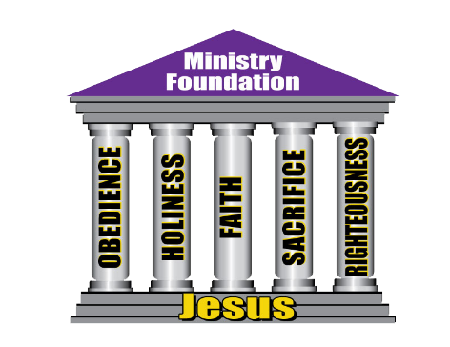
I encourage everyone to remain faithful during this period of consecration for the sake of God’s righteousness. I believe God will honor our requests as we take up this cross. Remember, fasting alone does not consecrate us; we must also dedicate our thoughts, expectations, and time. Commit to prayer and study during this consecration, keeping an open mind to God's will. It’s not about food but humility before God and connecting with Him. Fasting without a genuine spiritual connection is merely dieting. Keeping your heart and mind aligned with God’s purpose makes the fast meaningful.

Reflection:
_____________________________________________________________________________

_____________________________________________________________________________

_____________________________________________________________________________

_____________________________________________________________________________

_____________________________________________________________________________

_____________________________________________________________________________

_____________________________________________________________________________

_____________________________________________________________________________

_____________________________________________________________________________

_____________________________________________________________________________

_____________________________________________________________________________

_____________________________________________________________________________

_____________________________________________________________________________

_____________________________________________________________________________

Understanding

Prayer and Fasting

Why Does God Want Us to Pray?
Prayer is not made so that God can find out what we need, because Jesus tells us, “Your Father knows what you need before you ask him” (Matthew 6:8) (Grudem 2000)
For those of us who have been brought under the authority of Christ and the Bible, know that the will of God is for us to pray. But we also believe that His will is good towards us.
The Lord Jesus Christ, with all authority and love, expects us to pray. These extracts from His words show that He Himself expects us to pray:
- Matthew 6:5, “And when you pray ...”
- Matthew 6:6, “But when you pray …”
- Matthew 6:7, “And when you pray …”
- Matthew 6:9, “Pray then like this … “
- Luke 11:9, “And I tell you, ask …, seek …, knock.”
- Luke 18:1, “And he told them a parable to the effect that they ought always to pray.”
Prayer is essential during your fast. Prayer keeps you focused and in communication with God. God wants us to pray because prayer expresses our trust in Him and is a means by which our trust in him can increase.
In fact, perhaps the primary emphasis of the Bible’s teaching on prayer is that we are to pray with faith, which means trust or dependence on God, for God, as our Creator, delights in being trusted by us as His creatures.
Just in case you are like many people who wonder how to pray, Jesus gave the disciples the model for prayer. His disciples asked Him how to pray, and He gave them an example. How does the Lord's Prayer serve as a model for prayer?
The first words of the Lord’s Prayer, “Our Father who art in heaven” (Matthew 6:9), acknowledge our dependence on God as a loving and wise Father and also recognize that He rules over everything from His heavenly throne.
There are several elements to it:
- Recognition that God is who He says He is.
- Offering respect and acknowledgment to His supremacy
- Recognition that the universe is His
- Humility from the petitioner
- Request for the supply of daily needs for sustenance
- Acknowledging that there is evil, therefore, requesting aid/deliverance when confronted with it.
- Request for the forgiveness of personal sin and an attitude of forgiveness towards others
- Request for guidance
God not only wants us to trust Him; He also wants us to love Him and have fellowship with Him. As such, prayer will bring us into deeper fellowship with God, and He loves us and delights in our fellowship with Him.

The Effectiveness of Prayer (Grudem 2000)
- Prayer Changes the Way God Acts. James tells us, “You do not have, because you do not ask” (James 4:2). He implies that failure to ask deprives us of what God would otherwise have given to us. We pray, and God responds.

Jesus also says, “Ask, and it will be given to you, seek, and you will find; knock, and it will be opened to you. For everyone who asks receives, and he who seeks finds, and to him who knocks it will be opened” (Luke 11:9-10). Therefore, He makes a clear connection between seeking and receiving from God. When we ask, God responds.

We see this happening many times in the Old Testament. When God threatens to punish His people for their sins, He declares, “If my people who are called by My name humble themselves, and pray and seek My face, and turn from their wicked ways, then I will hear from heaven, and will forgive their sin, and heal their land” (2 Chronicles 7:14).

When God’s people pray (with humility and repentance), then He will hear and forgive them. The prayers of His people clearly affect how God acts. Similarly, “If we confess our sins, He is faithful and just, and will forgive our sins, and cleanse us from all unrighteousness” (1 John 1:9). In short, we confess, and then He forgives us.

See Genesis 18:22-33; 32:26; Daniel 10:12; Amos 7:1-6; Acts 4:29-31; 10:31; 12:5-11 (other examples of God answering prayer in Scripture).

- Effective Prayer is made possible by our Mediator, Jesus Christ: Because we are sinful and God is holy, we have no right on our own to enter his presence. We need a mediator to come between God and us, to bring us into God’s presence. The Scripture clearly teaches, “There is one God, and there is one mediator between God and men, the man Christ Jesus” (1 Timothy 2:5).
The Word tells us to pray without ceasing, but in many cases, we stop praying only when we do not immediately see results and assume God is not listening. Unanswered prayer can be very troubling and painful, so remember the following as you create a lifestyle of habitual prayer.
- When prayer does not bring results, it is an indication that something is wrong. The Word of God in the Old and New Testaments will provide insight into why prayers go unanswered, and the types of prayers God will respond to. God answers prayers as soon as we request, but the revelation of His answer is based on divine timing. Luke 18:1.
- God is faithful to answer prayer. We teach slang when things seem impossible, that it doesn’t have a prayer, but prayer is to show that nothing is impossible. Mark 11:24.
- God’s will and Word do work when they are understood and put into practice. Praying the Word of God should accompany understanding.
True prayer will do the following:
- Build intimacy with God.
- Bring honor to His nature and character.
- Cause respect for His integrity.
- Enable belief in His Word
- Cause trust in His love.
- Affirm His purpose and will.
- Appropriates His promise

What is Praying “in Jesus’ Name”? (Grudem 2000)
Jesus says, “Whatever you ask in My name, I will do it, that the Father may be glorified in the Son; if you ask anything in My name, I will do it” (John 14:13-14). He also says that He chose His disciples, “so that whatever you ask the Father in My name, He may give it to you” (John 15:16).
Similarly, He says, “And in that day ye shall ask Me nothing. Verily, verily, I say unto you, Whatsoever ye shall ask the Father in My name, He will give it to you. Hitherto have ye asked nothing in My name: ask, and ye shall receive, that your joy may be full” (John 16:23-24; KJV). But what does this mean?
To come in the name of someone means that another person has authorized us to go on his authority, not on our own. When Peter commands the lame man, “In the name of Jesus Christ of Nazareth, walk” (Acts 3:6), he is speaking in the authority of Jesus, not his own. When the Sanhedrin asks the disciples, “By what power or by what name did you do this?” (Acts 4:7), they are asking, “By whose authority did you do this?”
When Paul rebukes an unclean spirit “in the name of Jesus Christ” (Acts 16:18), he makes it clear that he is doing so in Jesus’ authority, not his own. Praying in Jesus’ name is, therefore, a prayer made by His authorization.

Praying with God's Word
If it is accepted that the Bible is God's inspired word, then praying His word will impact His will. "So shall My word be that goes forth from My mouth; it shall not return to Me, empty, without accomplishing what I desire, and without succeeding in the matter for which I sent it" (Isaiah 55:11). Additionally, faith is a necessary element: "And without faith it is impossible to please Him, for he who comes to God must believe that He is, and that He is a rewarder of those who seek Him" (Hebrews 11:6).

The Role of the Holy Spirit in our Prayer
In Romans 8:26-27, Paul says: “Likewise the Spirit helps us in our weakness; for we do not know how to pray as we ought; but the Spirit himself intercedes for us with murmurs too deep for words.
And He also searches the hearts of men and knows what the mind of the Spirit is, because the Spirit intercedes for the Saints according to the will of God.”
“The Spirit helps in our weakness” (v 26), the word does not indicate that the Holy Spirit prays instead of us, but that the Holy Spirit takes part with us and makes our weak prayers effective. Thus, murmuring or groaning in prayer is best understood as the murmur or groan we utter, expressing the desires of our heart and Spirit, which the Holy Spirit then makes into effective prayer.
To pray “in the Holy Spirit,” then, is to pray with the conscious awareness of God’s presence surrounding us and sanctifying both us and our prayers.

God Wants People to Pray
The Bible clearly declares that God wants people to pray to Him: Isaiah 64:7-8 says:
⁷ And there is none that calleth upon Thy name, that stirred up himself to take hold of Thee: for Thou hast hid Thy face from us, and hast consumed us, because of our iniquities. ⁸But now, O LORD, Thou art our Father; we are the clay, and Thou our potter; and we all are the work of Thy hand.
God’s Word makes it clear: the words of Jesus, the unmistakable expectation of God from the rest of the New Testament, are that we pray.
We should have continual prayer in our lives.
Colossians 4:2, “Continue steadfastly in prayer.” People who continue steadfastly in prayer have devoted themselves to pursuing a Christlike life where prayer is an ongoing priority. God expects believers to be devoted to prayer.
"...pray without ceasing..." I Thessalonians 5:17
While continuing steadfastly in prayer, prayer emphasizes prayer as an activity, praying without ceasing reminds us that prayer is also a relationship. Prayer is, in one sense, an expression of a Christian’s unbroken relationship with the Father.

Some essential considerations in Effective Prayer (Grudem 2000)
The Scripture indicates several considerations we should keep in mind if we would offer the kind of prayer God desires from us.
- Praying According to God’s Will. (1 John 5:14-15; Matthew 26:39). We should have great confidence that God will answer our prayer when we ask Him for something that accords with a specific promise or command of the Scripture.

- Praying with Faith. (Mark 11:24). Jesus is apparently saying that when we ask for something, the kind of faith that will bring results is a settled assurance. James tells us we are to “ask in faith, with no doubting” (James 1:6). Prayer is never wishful thinking, for it springs from trust in God who wants us to take Him at His Word.

- Obedience. Since prayer is a relationship with God, anything in our lives that displeases him will hinder prayer. See (Psalms 66:18; Proverbs 15:8, 29). In 1 Peter 3:12, Peter encourages good conduct in our everyday lives, in our speech, and in turning away from evil and doing right. He is saying that God readily hears the prayers of those who live in obedience to him.

- Confession of Sins. Because our obedience to God is never perfect in this life, we continually depend on his forgiveness for our sins. Confessing our sins is necessary for God to “forgive us” in the sense of restoring a day-by-day relationship with us (Matthew 6:12; 1 John 1:9).

- It is good when we pray to confess all known sin to the Lord and to ask for his forgiveness.

- Forgiving Others. Jesus says, “If you forgive men their trespasses, your heavenly Father also will forgive you” (Matthew 6:14-15). Similarly, Jesus says, “Whenever you stand praying, forgive, if you have anything against anyone” (Mark 11:25). Until sin is forgiven and the relationship is restored, prayer will, of course, be difficult. Moreover, if we harbor unforgiveness toward someone else, we are acting in a way that is neither pleasing to God nor helpful to us. So, God declares (Matthew 6:12, 14-15) that he will distance himself from us until we forgive others.

- Humility: James tells us that “God opposes the proud but gives grace to the humble” (James 4:6; also 1 Peter 5:5). Therefore, he says, “Humble yourselves before the Lord and he will exalt you” (James 4:10). Humility is thus the right attitude to have in praying to God, whereas pride is although inappropriate.

- Praying Earnestly. Jesus himself, who is our model for prayer, prayed earnestly. “In the days of his flesh, Jesus offered up prayers and supplications, with loud cries and tears, to him who was able to save him from death, and he was heard foe his godly fear” (Hebrews 5:7). Since God knows our heart, as a result, the intensity and depth of our emotional involvement in prayer should never be faked; we cannot fool God.

- Waiting on the Lord. After crying out to God for help in distress, David says, “Wait for the Lord; be strong, and let your heart take courage; yea, wait for the Lord!” (Psalms 27:14). See also Psalms 38:15; Psalms 130:5-6.

- Fasting. Prayer is often connected with fasting in Scripture. Fasting heightens spiritual and mental alertness and a sense of God’s presence as we focus less on the material.

Types of Prayer

What are the different kinds of prayer represented in the Bible?

Although there are many types of prayer, the following seven are the most common. Each prayer type has one or two scriptures that illustrate those prayers. Here are the seven main types of prayer:

Prayer of Worship – Hebrews 13:15 & Revelation 4:11 One of the biggest types of prayer is a prayer of worship. Worshipping the Lord focuses on who God is. It is we who recognize God’s power and majesty. These prayers can be as simple as, “God, you’re so good,” or as huge as in Revelation 4:11, “Worthy are you, our Lord and God, to receive glory and honor and power, for you created all things, and by your will, they existed and were created.” Worship can mean anything from singing praise songs, or it can mean simply doing what Hebrews 13:15 says, “Through him then let us continually offer up a sacrifice of praise to God, that is, the fruit of lips that acknowledge his name.”

Prayer of Thanksgiving – Psalms 100:4 Praying our thankfulness to the One who gave us what we have in our lives is another way we can pray. It is closely related to a prayer of worship, but the difference is that one recognizes who God is, while the other gives thanks to God for what He has done. Psalms 100:4 sums both of the prayer types up by saying, “Enter his gates with thanksgiving, and his courts with praise! Give thanks to him; bless his name!”

Prayer of Faith – James 5:13-16 When we pray in faith, we reaffirm that we have faith in God’s will. It isn’t us enforcing our will into His, but it is us conceding that His will be done. One example of this is in James 5:13-16, where it says, “13 Is anyone among you in trouble? Let them pray. Is anyone happy? Let them sing songs of praise. 14 Is anyone among you sick? Let them call the elders of the church to pray over them and anoint them with oil in the name of the Lord. 15 And the prayer offered in faith will make the sick person well; the Lord will raise them up. If they have sinned, they will be forgiven. 16 Therefore, confess your sins to each other and pray for each other so that you may be healed. The prayer of a righteous person is powerful and effective.”

Prayer of Intercession – Daniel 9:1-27 Intercession is the act of praying on behalf of another person or group of people. When we pray for the well-being of others, we are interceding on their behalf. There are many examples of this kind of prayer throughout the Bible, but a clear one is Daniel 9:1-27. In this passage, Daniel goes to the Lord and intercedes on behalf of his people. We can also do this in our lives.

Corporate Prayer – Acts 12:5-18 Corporate prayer is praying in a group. This can bring a sense of unity and community to you and your fellow believers. If you have been to a church service, then you have experienced this kind of prayer. An example of this type of prayer is in Acts 12:5-18. In this passage, the church is praying for Peter’s well-being.

Prayer of Consecration – Matthew 26:26- When we take communion, we are praying a prayer of consecration. This means we are consecrating the bread and wine (or grape juice) and asking God to make it holy. Jesus himself did this in Matthew 26:26-27, “26 While they were eating, Jesus took bread, and when he had given thanks, he broke it and gave it to his disciples, saying, “Take and eat; this is my body.” 27 Then he took a cup, and when he had given thanks, he gave it to them, saying, “Drink from it, all of you.”

Prayer of the Holy Spirit – Romans 8:26-27 Sometimes, we don’t know what we want or need to pray for at any given time. In Romans 8:26-27, the Bible says, “26 In the same way, the Spirit helps us in our weakness. We do not know what we ought to pray for, but the Spirit himself intercedes for us through wordless groans. 27 And he who searches our hearts knows the mind of the Spirit because the Spirit intercedes for God’s people in accordance with the will of God.”

https://www.orbcfamily.org/blog/prayer/7-different-types-of-prayer-in-the-bible/

When you pray, remember the following twelve biblical principles of your prayer life.
- Power and purpose of prayer by Dr. Myles Monroe
- Become Silent – Matthew 6:6 speaks of the first act of prayer. Get away from it all into a place where you will not be disturbed. Getting quiet helps you to eliminate distractions. Being peaceful and putting your mind on God also expresses your humility before Him. Isaiah 26:3 speaks of peace that is more than enough—meaning a place of prosperity.
- Give adoration – This step is the hallowing of the name of God (Luke 11:2). Adoration means worshiping God. When you adore someone, you express how precious they are to you.
- Confess – Confession is made when you allow the Spirit of God to speak of your sins and you come in agreement with them by confessing your condition, once it is exposed to you by the Holy Spirit. (Gal 5:16) In confession, gain forgiveness and purity. (1 John 1:9-10)
- Give thanks – After confessions, we should give thanks to God. (1 Thess 5:16-18) Thanksgiving at this point is primarily because your heart is free from the things you confessed.
- Make supplication – Philippians 4:6 speaks of the fact that we should not be anxious. But should instead go to Him in prayer and make our request known to God.
- Specify petitions and requests – When we come before the judge, we should be prepared and not use useless words. Know specifically what you want to request and know what the Word of God says concerning your desire. (Ecclesiastes 5:2) Be not rash with thy mouth, and let not thine heart be hasty to utter anything before God: for God is in heaven, and thou upon earth: therefore, let thy words be few.
- Secure the promises – This step is a part of step six. When you are petitioning God, you are doing it based on His promise. Embrace the promises of God. (2 Corinthians 1:20) Embrace that you are entitled to every promise God made to you. The answer to your needs regarding God's promises is Yes and Amen.
- Plead the case – Prayer is a legal art whereby you are talking to a just judge concerning your rights, as in Luke 18:1-8. In this chapter about the unjust judge, Jesus explains how to get your prayers answered.
- Believe – The power of our prayer is faith. Jesus speaks of the power of believing in Luke 18:22-24. Daniel 10:10-15 shows how, when Daniel prayed, God answered immediately. Mark 9:24 shows a man talking to Jesus, saying he considers but asking for help because he lacks faith. We cannot allow doubt to enter into our prayers. James 1:5-7 says our prayers should be without wavering.
- Give thanks – This is the second Thanksgiving and is different in reason, but the same in nature. Just as the Thanksgiving in the fourth step of prayer is for what God has divinely completed, this step is a thanksgiving for what God has divinely completed. In this, you are thanking God for what you don’t see, believing it is already done. Thanking God activates Angels (Hebrews 1:14).
- Live in expectation – Live in expectation, knowing that what is done in prayer is manifesting physically.
- Practice active belief – In Luke 11:1, Jesus starts with prayer but completes his teachings with ask, seek, and knock. This speaks to the life we live after prayer, indicating that we should not only expect what we requested, but also act as if it's available—searching for what God has done.

What’s your personal plan for prayer time?

______________________________________________________________________________

______________________________________________________________________________

______________________________________________________________________________

______________________________________________________________________________

There are six hurdles to answered prayer - Dr. Myles Monroe (Power and Purpose of Prayer)
- Learning about prayer but not practicing it – false sense of satisfaction.
- Mental assent, rather than action – agrees with God but does not believe.
- Hearing the words but not absorbing them – absorbing the Word is to meditate on it.
- Hoping, rather than having faith – This hope is wishful thinking, not biblical hope; faith is knowing.
- Praying for faith – If we are praying for faith, then we do not believe.
- Laziness/Cares of the world – Matthew 25:26 wicked service allows life concerns to keep us from the faith of work.
Major hindrances to prayer - Dr. Myles Monroe (Power and Purpose of Prayer)
- Sin - (James 1:21-22) tells us how prevalent it is that we must acknowledge our sins and our fallen nature. This state of humanity gives rise to many problems and misunderstandings regarding our faith, obedience, and prayer. When sin, especially willful sin, is in your life, God will not hear you. (John 3:22, 1 John 2:1).
- Fear - (1 John 4:18) Fear is a significant hindrance for us because it keeps us from believing. To operate in the Spirit, there has to be an absence of fear. 1 John 4:8 tells us that there is no perfection in fear. Fear will keep you in sin and keep our understanding of the nature and the work of God from our hearts (Romans 5:8-9; Matt 18:21-22; Isaiah 43:25; and 2 Tim 1:7).
- Guilt - Guilt is related to fear of not being forgiven. When we live in a constant sense of not being forgiven, we deny God's power in our lives. (Romans 8:1-2) Explains that there is no condemnation for those in Christ. We can have confidence in this because Hebrews 8:12 says God will forgive and forget our sins.
- Feeling of inferiority - We can hinder our prayers when we feel we are not worthy to receive an answer from God. We will only have a low opinion of ourselves when we do not understand how God sees us. (Ephesians 1:4-11) Explains how God sees us. Understanding that God chooses us changes our interaction with God. Hebrews 4:16 tells us to come boldly before the throne of grace.
- Doubt - (James 1:5-8) We tend to do this after going before God. It is believed that He can, even though one does not trust that He will fulfill His word.
- Wrong Motives - Since we know that God knows the heart, we should understand that God understands our motives before we come before Him. James 4:3 explains that when your supplications are based on lust, you will not get a response from God.

Reflection:
_____________________________________________________________________________

_____________________________________________________________________________

_____________________________________________________________________________

_____________________________________________________________________________

_____________________________________________________________________________

_____________________________________________________________________________

_____________________________________________________________________________

_____________________________________________________________________________

_____________________________________________________________________________

_____________________________________________________________________________

_____________________________________________________________________________

_____________________________________________________________________________

_____________________________________________________________________________

_____________________________________________________________________________

Why Fast?
Scripture presents fasting as a spiritual discipline with profound depth and purpose.
Jesus teaches that fasting should not be a performative act to gain human recognition, but a private spiritual practice between the individual and God. (Matthew 6:16-18).
True fasting goes beyond mere abstinence from food and involves actively caring for others- releasing oppression, feeding the hungry, sheltering the homeless, and clothing the naked (Isaiah 58:3-7).
It is fundamentally an act of returning to God with genuine heart-level repentance, accompanied by weeping and wailing (Joel 2:12-13).
Jesus also indicates that fasting has a temporal context, suggesting His disciples would fast after His departure (Matthew 9:14-15).
Early Christians practiced fasting to seek God’s guidance, with the Holy Spirit speaking to them during these periods of spiritual focus (Acts 13:2-3).
Importantly, Scripture warns against hypocritical fasting that is merely external or used as a means to justify transformation (Isaiah 58:3-7).
We fast to unlock divine resources or to strengthen our relationship with God. Isaiah 58 mentions several resources available, including protection, revelation, provision, revival, God’s presence, deliverance, and much more.
In the Old Testament, the Hebrew word for “fasting” meant “to cover your mouth.” In the New Testament, it means “not to eat. Therefore, biblical fasting is not eating. Fasting from television, radio, or other things is not biblical fasting. It could only be seen as abstinence. We cannot discount the significance and spiritual benefits of abstaining, but we cannot error it for fasting.

What makes Fasting Useless?
Isaiah 58 also describes the characteristics of a sour fast.
- Fasting for image – it is not for looking religious. Zach 7:5
- Fasting as a merit badge – To get merit with God. Isaiah 58:3
- Fasting to feed a religious spirit – Isaiah 58:3-4
- Fasting to form an illusion of godliness – Isaiah 58:5
- Grind off all religions – Because other religions fast.

Biblical Fasts
- The Esther Fast- a three-day -18) fast (no food or no water) for God’s favor (Esther 4:6). In times of trouble or great crisis, we should not fall apart. We should rise against the enemy.
- The Daniel Fast – a 21-Day Fast – Consisting of only vegetables, fruit, and water. – Daniel 10:2-3, Daniel 10:10-11, 14
- The Self-Examination Fast - the one-day fast – Leviticus 23:27. This is the fast indicated in Jeremiah 36:6. Before the Day of Atonement, God’s people went through a one-day fast for self-examination and consecration.
- The Fast before the battle – Judges 20. In this passage, we see God’s people consulting God for a battle. God permitted them on two occasions to go into battle, and they lost 40,000 soldiers in each pursuit. On the third approach, they fasted and gave burnt offerings. God then gave them the victory. We should never go into battle without fasting first.
- Fasting to lift the judgment of God. 1 Kings 21:27-29
- Fasting for healing – Isaiah 58:6-9. In this passage, you will find the quote, “Your healing will spring forth speedily.
- The Domination Fast – The forty-day fast – Matthew 4. Jesus fasted for 40 days before starting His ministry.

When you fast, you will lay a foundation for many generations. In Ezra 8:21, this is illustrated. In addition, the passage presents powerful reasons for fasting.
  - First, we fast to seek direction from God. God will reveal the right direction to go in when we are in transition. We should never make decisions without a fast first.
  - Secondly, we fast for our children. In Ezra, the text states that we can lay a foundation for generations through our fasting.
  - Thirdly, we fast for substance. See Ezra 21. We fast to petition God for our substance, resources, and finances. With this, we affirm that God is the source of our supply. We bring alive the words of the Psalmist, who declared, “The earth is the Lord’s and fullness thereof.”

Write some of the things you need to focus on during your Passion Fast:
“Be anxious for nothing, but in everything by prayer and supplication, with thanksgiving, let your requests be made known to God.” Philippians 4:6

WHAT IS FASTING?

Fasting is a spiritual discipline highlighted in the Bible. Jesus expected His followers to fast and indicated that God rewards those who do. Biblically, fasting involves voluntarily reducing or eliminating food intake for a specific time and purpose. This practice is seen in both the New and Old Testaments, indicating that it is a regular part of a believer’s life.

Matthew 6:16-18 (NASB) states:
“Whenever you fast, do not make a gloomy face as the hypocrites do, for they distort their faces to be noticed by others when they are fasting. Truly, I say to you, they have their reward in full. But when you fast, anoint your head and wash your face, so that your fasting will not be noticed by others but by your Father who is in secret; and your Father who sees what is done in secret will reward you.”

THE IMPORTANCE OF FASTING
In the Bible, God's people often fasted before significant victories, miracles, or answers to prayer, preparing them for blessings:
- Moses fasted: Before receiving the Ten Commandments.
  - Exodus 34:28 (NASB): “So he was there with the Lord for forty days and forty nights; he did not eat bread or drink water. And ^{[a]}He wrote on the tablets the words of the covenant, the Ten Commandments.”
- Israelites Fasted: Before a miraculous victory.
  - 2 Chronicles 20:2-3 (NASB): “Then some came and reported to Jehoshaphat, saying, 'A great multitude is coming against you from beyond the sea, from Aram; and behold, they are in Hazazon-tamar (that is, Engedi).” ³ Jehoshaphat was afraid and turned his attention to seek the Lord; and he proclaimed a period of fasting throughout Judah.”
- Daniel Fasted: To receive guidance from God.
  - Daniel 9:3 (NASB): “So I gave my [a]attention to the Lord God, to seek Him by prayer and pleading, with fasting, sackcloth, and ashes.”
- Nehemiah Fasted: Before starting a major building project.
  - Nehemiah 1:4 (NASB): “Now when I heard these words, I sat down and wept and mourned for days; and I was fasting and praying before the God of heaven.”
- Jesus fasted: During His victory over temptation.
  - Luke 4:2 (NASB): “for forty days, being tempted by the devil. And He ate nothing during those days, and when they had ended, He was hungry.”
- First Christians Fasted: During decision-making times.
  - Acts 13:2-3 (NASB): “While they were serving the Lord and fasting, the Holy Spirit said, 'Set Barnabas and Saul apart for Me for the work to which I have called them.” ³ Then, when they had fasted, prayed, and laid their hands on them, they sent them away.’

- Modern Christians are expected to Fast: Jesus declared we would fast.
  - Luke 5:35 (NASB) “But the days will come; and when the groom is taken away from them, then they will fast in those days.”
  - Mark 2:20 (NASB) “But the days will come when the groom is taken away from them, and then they will fast, on that day.”

TWO CAUTIONS
- Fasting is Not Earning: Fasting does not “earn” answers to prayer. God answers out of grace, and fasting helps prepare our hearts for His response.
- Health Considerations: Fast only if your health permits. If you can only manage a partial fast, do so in faith, and God will honor your intentions.

A CALL TO FAST

The Lord says, “Turn to me now, while there is time! Please give me your heart. Come with fasting, weeping, and mourning. Don’t tear your clothing in grief; instead, tear your hearts.”

Joel 2:12-17 (NASB):
“Return to the Lord your God, for he is gracious and merciful. He is not easily angered. He is filled with kindness and is eager not to punish you. Perhaps he will give you a reprieve, sending you a blessing instead of this terrible curse.”

- Fasting Starts with Leaders: Joel begins his urgent call to fast by addressing the elders.
- Spiritual Urgency: Fasting often reflects a sense of spiritual desperation.
- A Call to Return: God invites His people back to Him, emphasizing faithfulness over plans or strategies.
- Focus on the Heart: True fasting is about inner change, not just external practices.
- Response of a Broken Heart: Fasting, weeping, and mourning are appropriate responses to straying from God.
- Shared Responsibility: Fasting is a collective act that preserves God's reputation and glorifies His name.

Let us heed this call to fast and seek deeper connection and understanding from our Lord.

Reflection:
_____________________________________________________________________________

_____________________________________________________________________________

_____________________________________________________________________________

_____________________________________________________________________________

_____________________________________________________________________________

_____________________________________________________________________________

_____________________________________________________________________________

_____________________________________________________________________________

_____________________________________________________________________________

_____________________________________________________________________________

_____________________________________________________________________________

_____________________________________________________________________________

_____________________________________________________________________________

_____________________________________________________________________________

Prepare for the Fast
These are a few things you need to do to prepare yourself and your household for fasting:
- Establish a place and a time where you can pray. Prayer is critical while fasting; it is when you will experience a breakthrough and have what the Lord is saying to you.

- Plan to drink plenty of water during your fasting period.

- Establish a time for reading and meditating on the Word. Read the Word and think through what you have read.

- Your goal is closeness with God. Do not let the legalistic aspect of the fast crowd out the relational aspect.

- You must refrain from critical speaking and spreading negative words about or to anyone. If you have friends who tempt you into this lifestyle, you must plan to take a break from them.

- Limit watching and listening to the TV and Radio; focus on religious and educational shows, rather than things that could cloud your judgment.

- Establish a form of accountability during your fast, either a prayer partner or another person in the fast.

- Check your mind at all times. Remember, if it means nothing to you, then it will mean nothing to God. If you do not combine your fasting with prayer and the Word, it will mean nothing more than dieting.



Strengthening
Your Consecration

FASTING IS TO BE DONE FOR A PURPOSE
There is more to a biblical fast than merely abstaining from food. Fasting without a spiritual purpose is just a weight-loss fast.
Therefore, without a clear biblical purpose, fasting becomes an end in itself. Every hunger pang only makes you calculate the time remaining until you can eat.
Such thinking disconnects the experience in your mind and heart from the gospel and descends into the deception that perhaps your suffering will earn God’s favor.
As a believer, whenever you fast, you should do so for at least one of these biblical purposes:
- To Strengthen Prayer
- To Seek God’s Guidance
- To Express Grief
- To Seek Deliverance or Protection
- To Express Repentance and the Return to God
- To Humble Oneself Before God
- To Express Concern for the Work of God
- To Minister to the Needs of Others
- To Overcome Temptation and Dedicate Yourself to God
- To Express Love and Worship to God

Reflection:
_____________________________________________________________________________

_____________________________________________________________________________

_____________________________________________________________________________

_____________________________________________________________________________

_____________________________________________________________________________

_____________________________________________________________________________

_____________________________________________________________________________

_____________________________________________________________________________

_____________________________________________________________________________

_____________________________________________________________________________

_____________________________________________________________________________

_____________________________________________________________________________

_____________________________________________________________________________

_____________________________________________________________________________
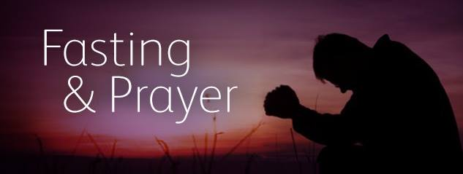

PRE-FASTING
Bible Study

The Biblical Doctrine of Fasting

Introduction:
- Probably very few of us ever fast.
- Fasting has become a very emotional issue for a lot of people and is often carried to extremes.
  - Some demand that we should fast.
  - Others don’t want anyone to tell them how to eat.
  - And others don’t want to be worried about more non-essentials.
- The list of people who have fasted is a virtual “Who’s Who” of Scripture.
  - Moses
  - Daniel
  - David
  - Anna
  - Elijah
  - Jesus
  - Esther
  - Paul
- There was not a single book published on the subject of fasting among our brethren from 1861 to 1954...yet we proclaim we want to restore N.T. Christianity.
- Let’s take a cursory look at fasting throughout the Bible and draw some conclusions.

Fasting In The Old Testament
A. The “Day of Atonement” was the only fast that was commanded by the Law (Leviticus 16:29-31; 23:26-32; Numbers 29:7).
1. Though not called “fasting,” the phrase “afflicting one’s soul” was used.
2. Thus, fasting was more than physical exercise, but had a spiritual purpose.

B. Other times when fasting occurred in the Old Testament.
1. Fasted in times of war or threat of war (Judges 20:26; 1 Samuel 7:6).
2. Fasted when loved ones were sick (2 Samuel 12:16-23).
3. Fasted for their enemies (Psalm 35:11-13).
4. Fasted when loved ones died (1 Samuel 31:13; 1 Chronicles 10:12).
5. Fasted when seeking God’s pardon (Deut. 9:15-18; 1 Kings 21:17-29; Jonah 3:4-10).
6. Fasted when facing danger (Ezra 8:21; Esther 4:3, 4:16).
7. Fasted to commemorate certain calamities (Jeremiah 52:12-13; 2 Kings 25:23- 25; Jeremiah 41; 2 Kings 25:1, 3-4).

Fasting In The New Testament
A. Fasting and Jesus.
1. Jesus fasted forty days (Matthew 4:1-9; Luke 4:1-2).
2. Jesus taught about fasting in his sermon on the mount (Matthew 6:16-18).
3. Jesus was questioned about it by John’s disciples (Matthew 9:14-17).
4. Jesus taught of a combined power of prayer and fasting (Mt. 17:14-21).

B. Fasting and the Church.
1. The church at Antioch fasted (Acts 13:1-3).
2. The churches of Galatia fasted (Acts 14:21-23).
3. The apostles fasted (1 Corinthians 6:1-10).
4. Paul often fasted (2 Corinthians 11:23-27).
5. Married couples may find a need for fasting (1 Corinthians 7:5).

Purpose Of Fasting
A. Some fasting was the natural reaction to grief.
B. But more often, fasting was done to purposely “afflict the soul.”
C. The purpose of this affliction was to “humble” the soul (Psalm 35:13).
D. Evidently, they felt that by so humbling themselves, they would more likely secure God’s favor and blessings (Ezra 8:21-23; Isaiah 57:15; 66:1-2).

Nature Of Fasting
A. The usual form of fasting was to abstain from all food, but not water.
B. Sometimes a fast was partial, restricting the diet, but not total abstention (Daniel 10:2- 3).
C. Sometimes a fast was absolute, including water (Jonah 3:5-10; Esther 4:16; Acts 9:9).

Length Of Fasting
A. One day [Sunrise to sunset] (Judges 20:26; 1 Samuel 14:24; 2 Samuel 1:12; 3:35).
B. Three days (Esther 4:16).
C. Seven days (1 Samuel 31:13; 1 Chronicles 10:12).
D. Forty days (Exodus 34:28; Deuteronomy 9:9; 1 Kings 19:8; Matthew 4:2).

Warnings Concerning Fasting
A. It can turn into an empty ritual (Isaiah 58:3-9).
B. It can be turned into a show (Matthew 6:16-18).

Summary Of Thoughts On Fasting
A. Should Christians fast today?
1. Yes, but not the difference in “should” and “must.”
2. Jesus assumed that his disciples would fast (Matthew 9:14-15).
3. We should fast because Jesus expected us to and the N.T. church practiced it.
B. Why Should Christians Fast?
There are times when we need divine help (in times of temptation, illness, beginning a new work, appointing elders, in times of war, seeking forgiveness).
C. How should Christians fast?
1. Not to be seen of men (Matthew 6:16-18).
2. Not as some regular ritual (Matthew 9:14-17).
3. Not without true repentance (Isaiah 58:3-9).

Conclusion:
1. Fasting is not a church ordinance, but rather it is a private matter.
2. The church can be called to fast, but the choice is yours.
3. Jesus expects you to fast; but the choice is yours.
4. Fasting...the choice is yours.

Lesson 1
An Unrelenting Persistence
Matthew 11: 11-12 KJVS
“Verily I say unto you, Among them that are born of women there hath not risen a greater than John the Baptist; notwithstanding he that is least in the kingdom of heaven is greater than he. And from the days of John the Baptist until now the kingdom of heaven suffereth violence, and the violent take it by force” (KJV).
Jesus reminded them that John was God’s chosen herald of the Messiah, and not a man-pleaser or self-pleaser (11:10). He was, in fact, more than a prophet, because he alone had the ministry of serving as the Messiah’s herald. For that, he was the greatest of prophets and the greater of men (among those born of women, there has not risen one greater than John the Baptist).
Here, Matthew noted that this ministry of the messiah’s herald was prophesied in Isaiah 40:3 and Malachi 3:1.
For John had often borne the witness of Jesus; now Jesus bears witness of John.
- John was steady, not shaking easily like a reed.
- John was sober, in that he lived a disciplined life, not in love with the luxuries and comforts of the world.
- John was a servant, a prophet of God.
- John was sent as the special messenger of the Lord.
- John was special in that he could be considered the greatest under the Old Covenant
- John was second to even the least in the kingdom under the New Covenant

He who is least in the kingdom of heaven is greater than he: Although John was great; he was not born again under the New Covenant because he lived and died before the completion of Jesus’ work at the cross and empty tomb. Therefore, he did not enjoy the benefits of the New Covenant (1 Corinthians 11:25, 2 Corinthians 3:6, Hebrews 8:6-13).
The kingdom of heaven suffers violence, and the violent take it by force: Jesus’ reference to both the intensity of spiritual warfare surrounding the ministry of Jesus and His herald (also the intensity required to persevere in following God and His kingdom).

For a divine moment, we will need to press toward who we are in Jesus Christ and abandon the following:
- Our comfort
- Our knowledge
- Our perception
- Our current profession
To embrace the kingdom of God, you must
- Embrace Jesus as the entry point to the kingdom.
- Embrace that we have a mandate for the benefit of the King and not ourselves.
- Embracing that my will is not necessarily the will of the King.
- Rest in the fact that My King provides for everything He wants me to do.
- With that, I can deploy, disciple, and dominate in the name of Jesus.

What does embodying a mandate of Deployment, Discipleship, and Domination look like?
- It requires faith that works according to God (Matthew 11:3)
John is sitting on death row in prison and is concerned about a prophecy he has already confirmed under the power of the Holy Spirit.
In the last days of his life while in prison, he reflects on what he said Jesus would do and now is questioning if he got it right.
John the Baptist is showing one of the greatest temptations we have in humanity.
We look for a God that we created in our minds according to our expectations.
God never moves in a way that is comfortable for you, and I need to recognize God within my discomfort situation.

- It requires infant-like embodiment (Matthew 11:25)
After Jesus reflected on the identity of John, the work of John, and the ignorance of humanity, he thanks God.
The people that appreciate the hand of God are the people that reaches to God like an infant.
Even though we are not getting it perfectly right, we should lean in and trust, depend, and lean on Jesus.
When we lean into God with no presupposition, we take the limits off God.

- It requires unrelenting persistence (Matthew 11:12)
Jesus, after explaining the ministry and the impact of John the Baptist, now explains the nature of God.
We must have a drive for the kingdom that is driven in a way that cannot stop us.
It has to mirror the drive of Christ in his suffering (Philippians 3:13; 2 Timothy 4:7; Isaiah 1:12; Deuteronomy 31:6).
In 2026, we have got to press when it’s good, and when it’s bad.

- It ultimately brings rest (Mathew 11:29)
In 2026 there are two type of rest we are seeking in Christ
The first rest is immediate.
As we take on this mandate for Christ being fully surrendered, we find a position of rest (Philippians 4:11; Hebrews 4:3).
This is a rest that keeps you in peace regardless of what goes on around you.
When you are fully engaged in Christ from the proper perspective, you find rest and peace in Christ.
The second rest is in our glorified state (Hebrews 4:9-11)

NOTES: ________________________________________________________________________________________________________________________________________________________________________________________________________________________________________________________________________________________________________________________________________________________________________________________________________________________________________________________________________________________________________________________________________________________________________________________________________________________________________________________________________________________________________________________________________________________________________________________________________________________________________________________________________________________________________________________________________________________________________________________________________________________________________________________________________________________________________________________________________________________________________________________________________________________________________________________________________________________________________________________________________________________________________________________________________________________________________________________________________________________________________________________________________________________________________________________________________________________________________________________________________________________________________________________________________________________________________________________________________________________________________________________________________________________________________________________________________________________________________________________________________________

Lesson 2
Hebrews 4:3-11 KJVS
The Revelation of Resting in God
“For we which have believed do enter into rest as he said, As I have sworn in my wrath, if they shall enter into my rest, although the works were finished from the foundation of the world. For he spake in a certain place of the seventh day on this wise, And God did rest the seventh day from all his works.
And in this place again, if they shall enter into rest.
Seeing therefore it remaineth that some must enter therein, and they to whom it was first preached entered not in because of unbelief. Again, he limiteth a certain day, saying in David, Today, after so long a time; as it is said, Today if ye will hear his voice, harden not your hearts. For if Jesus had given them rest, then would he not afterward have spoken of another day.
There remaineth therefore a rest to the people of God. For he that entered into his rest, he also hath ceased from his own works, as God did from his. Let us labour therefore to enter into that rest, least any man fall after the same example of unbelief.”

The rest for God’s people is like God’s rest (Hebrews 4:3-5). We who believed do enter that rest.
- Faith is the key that opens the door.
- Today, believers enjoy the rest of conscience because they know that they will never be brought into judgment for their sins (John 5:24).
- But it is true that those who believe are the only ones who enter God’s final rest in glory.
“So, I swore in My wrath, They shall not enter My rest: (quoted from Psalm 95:11).
- Just as faith admits, so unbelief excludes.
- We would trust Christ are sure of God’s rest.
- The unbelieving Israelites could not be sure of it because they did not believe God’s word.
- Unbelief keeps many out of God’s rest, faith guides God’s people into this rest.
- This quote from Psalms 95:11 demonstrates that this rest is God’s; it is His rest.
- God finished His work of creation long before Israel came into Egypt or before David wrote Psalm 95 (Genesis 2:2)
- This rest is after the pattern of God’s own rest on the seventh day from all His works, as described in the quote from Genesis 2:2
Without Christ, we find ourselves aimless, tired, stressed, and seeking fulfillment in things that will not bring peace.
- From creation, God has been offering rest to mankind.
- The admission gate has been open.
- The Israelites in the wilderness failed to enter because of their disobedience.
- In David’s time, God was still pleading with men to trust Him and not to harden their hearts.
- Some Israelites did, of course, enter Canaan with Joshua, but even these did not enjoy the final rest which God has prepared for those who love Him.
There remains therefore a rest for the people of God (4:9)
- The Greek word for rest (sabbatismos), which is related to the word Sabbath.
- It refers to the eternal rest which will be enjoyed by all who have been redeemed by the precious blood of Christ.
- It is a “Sabbath” keeping that will never end.
Whoever enters God’s rest enjoys a cessation from labor, just as God did on the seventh day (4:10)
- Before we were saved, we may have tried to work for our salvation.
- When we realized that Christ had finished the work at Calvary, we abandoned our own worthless efforts and trusted the risen Redeemer.
- After salvation, we expend ourselves in loving toil for the One who loved us and gave Himself for us.
- Our good works are the fruit of the indwelling Holy Spirit.
- In God’s eternal rest, we shall cease from our labors, worries down here.
- But in heaven we shall worship and serve Him; there will be no fatigue, distress, persecution, or affliction.
- We cease from self-justifying works because Jesus finished the work on the cross.
Applying the idea and the invitation to enter God’s rest through faith (4:11)
God’s rest is still available. Be diligent to enter that rest:
- The rest is there, but God does not force it upon us.
- We must enter that rest clearly by faith and it takes diligent faith.
- This shows us that faith is not passive; it takes diligence to trust in, rely on, and cling to Jesus and His work for us.
- We must be diligent to make sure that our only hope is Christ the Lord.
- We must diligently resist any temptation merely to profess faith in Him and then to renounce Him in the heat of suffering and persecution.
- The Israelites were careless, for they treated God’s promises lightly.
- They yearned for Egypt, the land of their bondage.
- They were not diligent in appropriating God’s promises by faith, as a result, they never reached Canaan, we should be warned by their example.
- If we are not diligent to enter that rest, the result can be a disaster.
- We may fall according to the same example of disobedience as the children of Israel did in the wilderness.

NOTES:
________________________________________________________________________________________
________________________________________________________________________________________
________________________________________________________________________________________
________________________________________________________________________________________
________________________________________________________________________________________

Lesson 3
Joshua 1:8-11
The Art of Deployment
“This book of the law shall not depart out of thy mouth; but thou shalt meditate therein day and night, that thou mayest observe to do according to all that is written therein; for then shall make thy way prosperous and then thou shalt have good success. Have not I commanded thee? Be strong and of a good courage; be not afraid, neither be thou dismayed; for the Lord thy God is with thee whithersoever thou goest.
Then Joshua commanded the officers of the people saying, Pass through the host, and command the people, saying Prepare you victuals; for within three days ye shall pass over this Jordan, to go in to possess the land, which the Lord your God giveth you to possess it.”

Joshua is being called into ministry of the deployment of Israel
Three times Joshua is told by the Lord to be strong and very courageous (vv. 6,7,9)
- The size and duration of the task ahead, the pressures of leading such obstinate people.
- Joshua was likely weighed down by the absence of his spiritual mentor, Moses, during this period.
- But the Lord was not calling him without enabling him.
- There were good reasons for Joshua to be strong.
- God’s promise (vv. 5, 6), a sure victory; God’s Word (vv.7,8), a safe guide; God’s presence (v.9), a sustaining power.
How to Prepare for Deployment:
- Keep the Word of God as central conversation and meditation (1:8)
- Joshua must take great care to observe the law.
- God’s word and Joshua’s commitment to it will be the pillars supporting his success.
- Joshua did not only need to read God’s word. It had to be on his lips (shall not depart from your mouth), in his mind (meditate in it day and night), and he had to do it (observe to do according to all that is written).
- God’s word so lived is a guarantee of Christian success.
- Not that it promises a life without problems, but it does ensure a life able to deal with anything.
- Because it takes full advantage of God’s presence and promises.
“And Christian success is not measured by the same standards as the world’s success. Even if the world accounts us as sheep for the slaughter, we are actually more than Conquerors through Him who loves us” (Romans 8:36-37).
Joshua, after watching the effects of not trusting God, embraced his calling to deploy the children of Israel into the promised of God.
The name Joshua means “Yahweh is salvation”, indicating that his name reflected the way he embraced the promise of God.
The hindrance in embodying the divine call we have from God to deploy is tied to a lack of trust in God.
- Worring excessively: Anxiety about things you cannot control (finances, future) shows reliance on self, not God.
- Seeking your own solutions: Distracting yourself or trying to fix problems outside of God’s guidance.
- Pushing God away: Stopping prayer, communication, or reliance on Him.
- Focusing on the negative: Seeing problems more than God’s presence or work.
- Ignoring His word: Not listening to or studying His guidance.

- Keep your strength in the Lord and resist fear with courage (1:9)

The final encouragement, repeated from (1:5), reminds us that Joshua’s success did not depend solely on his ability to keep God’s word. It depended even more on God’s presence with him.
- What Joshua was about to embark on was bigger than him?
- The generation before the generation he was leading described the endeavor as confronting giants.
- But God had given Joshua and his generation a testimony.
- In Numbers 21:21-31, the children of Israel defeated Og the king of Bashan whose iron bed was 13.5 feet long.
- Joshua’s testimony had to be if God did it before, He can do it again.
- The text states that God instructed Joshua to be strong and of good courage.
- Courage requires that we make ourselves alert to God’s power. His promises, and His providence in every situation.
- God warned Joshua to not be dismayed.
- Some of us are dealing with shattered life, broken promises, and systematic failure.
- But I want you to know that if you are breathing right now, God still can make a way out of no way.
- “Ye are of God, little children, and have overcome them, because greater is he that is in you, than he that is in the world” (1 John 4:4, KJVS).

- For within three days (1:10-11)
- Waiting for God is often the most difficult part for us, but days of waiting are always days of preparation in God’s work.
- There is no wasted time with God.
- Embrace a promised rest in the deploying in the Lord, “Remember the word which Moses the servant of the Lord commanded you, saying, The Lord your God hath given you rest, and hath given you this land” (Joshua 1:13, KJVS).

Lesson 4
Matthew 28:18-20
The Mandate of Discipleship
“ And Jesus came and spake unto them, saying, All power is given unto me in heaven and in earth. Go ye therefore, and teach all nations, baptizing them in the name of the Father, and of the Son, and of the Holy Ghost: Teaching them to observe all things whatsoever I have commanded you: and, lo, I am with you always, even unto the end of the world. Amen.”
The Great Commission given to all believers is to stay in motion with a kingdom mandate.
While we are in motion we are to:
- Teach every nationality.
- Baptize the nations.
- Teach them to observe all the things Jesus commanded.
Jesus is our Lord and He has all authority
- He commands us to take the gospel to all nations.
- He promises to be us always.
- What more assurance could we want?
- We are His ambassadors (2 Corinthians 5:20) and should be faithful to Him in all things.
The major themes of the Gospel:
- Christ’s divine sovereignty and authority.
- The nature of discipleship.
- The universal scope of Christian faith.
- The importance of doing the will of God.
- The promise of Christ’s presence with His followers in everything they may experience.
- Verse 19 has understandably come to be known as the Great Commission.
- Believers’ task in life in essence is to duplicate themselves in others.
- Leading men and women in every part of the world to faith, baptism, and obedience to all of Christ’s commands.
- The final word is to return our focus to Christ rather than keeping it to ourselves.
- Even when we are faithless. He remains faithful.
The Great Commission contains three commands, not suggestions:
- “Go therefore and make disciples of all nations.”
By preaching the gospel, the disciples were to see others become learners or followers of the Savior (from every nation, tribes, people, and tongues.
- Baptize “them in the name of the Father and of the Son and of the Holy Spirit.”
The responsibility rests on Christ’s messengers to teach baptism and to press it as a command to be obeyed.
In believers’ baptism, Christians publicly identify themselves with the Triune Godhead.
They acknowledge that God is their Father, that Jesus Christ is their Lord and Savior, and that the Holy Spirit is the One who indwells, empowers, and teaches them.
- Teach “them to observe all things that I have commanded you.”

The Great Commission goes beyond evangelism; it is not enough to simply make converts and let them fend for themselves.

They must be taught to obey the commandments of Christ as found in the New Testament.

The essence of discipleship is becoming like the Master, and this is brought by systematic teaching of, and submission, to the Word.
Then the Savior added a promise of His presence with His disciples until the consummation of the age
- They would not go forth alone or unaided because they would know the companionship of the Son of God
- Notice the four “Alls” connected with the Great Commission: all authority; all nations; all things; always.
- Thus, the Gospel closes with commission and comfort from our glorious Lord.
- Nearly twenty centuries later His words have the same power, the same relevance, the same application.
- What are we doing to carry out His last command?
NOTES: ________________________________________________________________________________________________________________________________________________________________________________________________________________________________________________________________________________________________________________________________________________________________________________________________________________________________________________________________________________________________________________________________________________________________________________________________________________________________________________________________________________________________________________________________________________________________________________________________________________________________________________________________________________________________________________________________________________________________________________________________________________________________________________________________________________________________________________________________________________________________________________________________________________________________________________________________________________________________________________________________________________________________________________________________________________________________________________________________

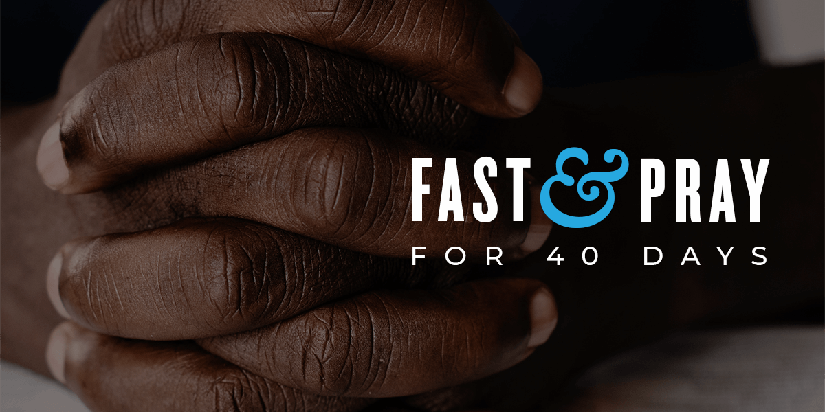


When giving an offering, fasting is more about your heart. We cannot trick God into blessing us; our hearts must be in the right place to receive the Lord's blessings. I believe if we make a heart sacrifice during this fast, God will respond because we are operating in the Word of God.
FASTING
Bible Study

2026 Consecration

40-Day Dominion Fast
Beginning February 24, 2026
21-Day Daniel Fast
Beginning March 15, 2026

Theme – OUR YEAR OF DEPLOYMENT, DISCIPLESHIP, DOMINATION

Purpose: This consecration strongly emphasizes faith in uncertain moments, the need for persistence, humility, and spiritual rest, as well as the call to communal courage and prophetic expectation for 2026. We should approach this year with childlike faith, deep trust, and a commitment to be vessels for God’s peace and revelation. While we all press forward together into a “new awakening.”
Scripture References: Ephesians 4:13, 1 Corinthians 12:27, Romans 14:19, Ephesians 3:5, Philippians 3:8, 1 Corinthians 2:6, Colossians 1:28, John 1:16, Ephesians 1:23, Ephesians 3:19, Daniel 7:27, 2 Corinthians 12:9, Hebrews 4:3-9, Deuteronomy 31:6, 2 Timothy 4:7, Philippians 3:13, Matthew 11-25, John 20:21, 2 Timothy 2:2, Luke 9:23, John 8:31, Romans 12:2, Genesis 1:28, Mark 16:15, Acts 1:8, Matthew 5:13-16,
Expected Results:
- Clarity of Assignment (Deployment) - Shift from preparation mode to deliberate and intentional action.
- Strengthened Spiritual Authority (Dominion) - stop reacting to circumstances and start governing them.
- Reproducible Mindset (Discipleship) - disciples who can make other disciples, not just attend programs.
- Purified Desires and Aligned Habits – a lifestyle changed, not just a temporary spiritual high.
- Collective Momentum and Strategic Impact - people who move together with focus, speed, and authority.

This fast is a consecration to.

40-DAY FAST
Feb 24 No meat (You may have freshwater fish only)
March 6: No meat and no fish
March 16 Fruit, Vegetables, and Water only

21-DAY FAST
March 15 Fish, Fruit, and Vegetables
March 22 Days of no meat and no fish
March 29 Fruit, Vegetables, and Water only

March 26 Eden Fast (Seed Bearing meat)

Other Variations for Consecration:
40 Days – One (1) Meal per Day
One balanced meal at the same time daily, liquid meal replacement for other meals.
40 Days Liquid Fast
Some may choose to eat only fruit, vegetables, or liquids for the whole fast. You have that liberty.
Monday through Friday
No food or one meal a day, Monday through Friday, no fasting on weekends (Saturday and Sunday

The fast will also include abstinence and behavioral modification. Please see below a list of things we must do during this fast.

- Limit the amount of Television and Radio (Substitute with Religious Programming).

- No excess spending. Pay your bills and buy your necessities, such as groceries and medicines. Refrain from eating out unless you have to because of employment or prescheduled events.

- Whenever you want to spend money, take the money you would have used for an item of desire and put it into savings. Keep a list of the things you desire.

- Keep your thinking and conversations positive. Phil 4:8

- Seek opportunities for community service to people with low incomes and disenfranchised while fasting.

- Some may have birthdays, anniversaries, and major family events during the fast. This year, you and your family may break the fast for that one day for the special event and immediately return to the fast's restrictions thereafter.

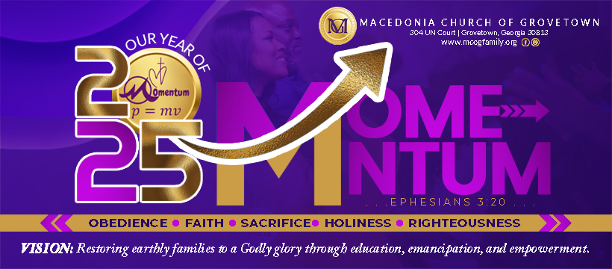
**Due to health restrictions, some people may not be able to complete every aspect of the fast. Please consult your doctor before entering this fast. At a minimum, go as far as your health will allow.**

Reflection:
______________________________________________________________________

______________________________________________________________________

______________________________________________________________________

______________________________________________________________________

______________________________________________________________________

______________________________________________________________________

______________________________________________________________________

______________________________________________________________________

______________________________________________________________________

______________________________________________________________________

______________________________________________________________________

______________________________________________________________________

______________________________________________________________________

21-Day Dominion Fast Daily Log
My twenty-one day Fast Begins __________ (dates) and ends on __________ (dates).
The reason I'm fasting:
____________________________________________________________________________
____________________________________________________________________________
____________________________________________________________________________
____________________________________________________________________________

From what am I fasting?
____________________________________________________________________________
____________________________________________________________________________
____________________________________________________________________________
____________________________________________________________________________

The results of my Perfection Fast
1st seven days ______________________________________________________________________
2nd seven days ______________________________________________________________________
3rd Seven Days ____________________________________________________________________________

Testimonies I will share:
____________________________________________________________________________
____________________________________________________________________________
____________________________________________________________________________
____________________________________________________________________________
____________________________________________________________________________

40-Day Dominion Fast Daily Log
My forty day Fast Begins ____________ (dates) and ends on ______________ (dates).
The reason I'm fasting:
____________________________________________________________________________
____________________________________________________________________________
____________________________________________________________________________
____________________________________________________________________________
From what am I fasting?
____________________________________________________________________________
____________________________________________________________________________
____________________________________________________________________________
____________________________________________________________________________
The results of my Perfection Fast
1st Ten days ______________________________________________________________________
2nd Ten days ______________________________________________________________________
3rd Ten Days ______________________________________________________________________
4th Ten Days ____________________________________________________________________________

Testimonies I will share:
____________________________________________________________________________
____________________________________________________________________________
____________________________________________________________________________

____________________________________________________________________________

